

**A211 STIA1113 – PROGRAMMING 1 (GROUP C)**

**ASSIGNMENT 2**

**NAME: NOR AISYAH BINTI ABD HALIM**

**MATRIC NUMBER: 286982**

**TOPIC: BANK**

**SUBTOPIC: BUSINESS LOAN**

**LECTURER: PROF. MADYA DR. AZMAN B YASIN**

**DUE DATE: 15 JANUARY 2022**

1. **Identify the problem**

Small and mid-size enterprises (SMEs) are businesses that maintain [revenues](https://www.investopedia.com/terms/r/revenue.asp), [assets](https://www.investopedia.com/terms/a/asset.asp) or a number of employees below a certain threshold. Each country has its own definition of what constitutes a small and medium-sized enterprise (SME). Certain size criteria must be met and occasionally the industry in which the company operates in is taken into account as well.

SME finance is the funding of small and medium-sized enterprises, and represents a major function of the general business finance market – in which capital for different types of firms are supplied, acquired, and costed or priced. Capital is supplied through the business finance market in the form of bank loans and overdrafts; leasing and hire-purchase arrangements; equity/corporate bond issues; venture capital or [private equity](https://en.wikipedia.org/wiki/Private_equity); asset-based finance such as [factoring](https://en.wikipedia.org/wiki/Factoring_(finance)) and [invoice discounting](https://en.wikipedia.org/wiki/Discounting), and government funding in the form of grants or loans.

The SME Loan provides a single line of credit for meeting the borrowing needs of SME. It can be used as a working capital as well as for long-term requirements. It is approved after considering the nature of business, cyclical trends, cash flow projections, and peak time requirements.

Maybank is [Malaysia](https://en.wikipedia.org/wiki/Malaysia)'s largest bank by market capitalisation and total assets and [one of the largest banks in Southeast Asia](https://en.wikipedia.org/wiki/List_of_largest_banks_in_Southeast_Asia), with total assets exceeding US$203 billion and having a net profit of US$1.98 billion for 2019.

Maybank is also ranked 106th in The Banker's 2020 Top 1000 World Banks (as at July 2020) and is ranked 349th in the Forbes Global 2000 Leading Companies (as at May 2020).

Maybank is the largest public listed company on Bursa Malaysia, the Malaysian stock exchange, with a market capitalisation of US$23.7 billion as of 31 December 2019.

* Information:

1. Eligibility:
2. Below RM25 million annual sales turnover
3. Below RM5 million outstanding loan/ financing with Maybank
4. Malaysian-owned registered company

|  |  |  |
| --- | --- | --- |
|  | Online Application | Branch Application |
| Financing amount | RM10,000 – RM250,000 | RM50,001– RM1,500,000 |
| Approval time | * 10 minutes if you are an existing Maybank customer. * Approximately 48 hours if you are new to Maybank. | Determined on a case-by-case basis |
| Required documents | * No documents required if you are an existing Maybank customer. * If you're new to Maybank: * NRIC of Directors /Shareholders/Proprietors /Partners/ guarantors * Business Registration documents | * NRIC of Directors /Shareholders/Proprietors /Partners/ guarantors * Business Registration documents * Latest 6 months bank statement from any bank |
| Security requirements | None | * Joint and Several Guarantee from all the directors (for Sdn. Bhd. only) * Corporate Guarantee (from Parent companies, if applicable) |
| Financing tenure | Up to 5 years | Up to 7 years |
| Business operation period | Minimum 1 year | Minimum 3 years |

Calculation:

Monthly payment:

Using formula:

where

P = loan amount

i = monthly interest in decimal

n = loan term in years

1. **Understand the problem**

Due to Covid-19 pandemic, most of business person having trouble with money because they have to close the store. To prevent from bankruptcy, most of them want get a loan. Due to pandemic, everyone must stay at home and need to make an appointment first to walk into the branch. The customer has to wait until that day to go to the branch to get a loan and it will take a lot of time for them to get a loan.

1. **Identify alternative ways to solve the problem**
2. The system will give the information about SME Clean Loan and check whether the customer is qualify or not and if the customer can make a loan, the sysem will calculate the monthly payment for the customer.
3. The system will give information about loan and the customer will make a decision him/herself based on his/her eligibility..
4. **Select the best ways to solve the problem from the list of alternative solutions**

The system will give the information about SME Clean Loan and the qualification to apply that loan. The user will enter the information about him/herself (name, age, number phone), loan amount, duration loan and the system will calculate the monthly payment.

1. **List instructions that enable you to solve the problem using the selected solutions**
2. Use the information from the customers.
3. The system will give information of SME Clean Loan.
4. The customer will enter the amount of loan and duration loan.
5. The system will chech the qualification of customer.
6. The system will calculate the monthly payment based on amount of loan and loan duration.
7. The system will shows the monthly payment and total payment to customer.
8. The system will give recommendationto the customer whether to apply online or walk into the branch.
9. **Evaluate the solution**

In the end by using the system will help the customer to be more understand about business loan and will be easier for the customer to get a loan. SME Clean Loan give many benefits to customer. First, it is easy & quick because nowadays it can be applied online or at branch. Other than that, it has low rates and charges. It is also didn’t need collateral to apply loan. Monthly payment is calculated to help the customer experiment with different loan amounts and loan durations so they can figure out the suitable loan amount they would be able to take out without causing any inconvenience to their finances, and the period of time within which they can comfortably repay the loan.

1. **Algorithm**
2. Start
3. Enter your name, phone number and age.
4. Display information about SME Clean Loan.
5. Enter outstanding loan with Maybank (if any).
6. Enter the number of loan that have make before (if any).
7. Enter the amount of loan (if any).
8. Enter business operation period and annual revenue.
9. Enter amount of loan and loan duration.
10. System calculate the the monthly payment and total payment.
11. Display name, monthly payment and total payment.
12. End
13. **Pseudocode**

Start

Initialize total to 0

Output “Enter your name”

Input name

Output “Enter your number phone”

Input number phone

Output “Enter your age”

Input age

Display information about SME Clean Loan

Display eligibility

Display types of application method

Display information about online application

Display information about branch application

Output "The interest rate is 4.5%."

Output "No collateral needed."

Output “Do you have outstanding loan with Maybank ( 1 for yes | 2 for no):”

Input answer

If (answer = 1) Then

Output "How many loan did you make before: "

Input loan

Initialize int i to 1

For i ≤ loan

Input LoanAmount

total = total + LoanAmount

Output "Your total outstanding loan is " + total

If (total > 5000000) Then

Output "Sorry your outstanding loan is greater than 5 millions. You can't apply SME Clean Loan."

Else

Output "Enter business operation period (in months): "

Input period

Output "Enter your annual revenue: "

Input revenue

If ((period >= 12) && (revenue <= 25000000))

Output "Enter the amount of loan: "

Input amount

Output "Enter financing tenure: "

Input tenure

If ((amount >= 10000) && (amount <= 250000) && (tenure <= 5))

Output "You can apply SME Clean Loan via online application using this link (<https://www.maybank2u.com.my/home/m2u/common/page/apply/RSME.do?productType=RSME>)"

ElseIf ((amount >= 50001) && (amount <= 1500000) && (tenure <= 7))

Output "You can apply SME Clean Loan via branch application"

Initialize interest to 0.045

Calculate monthly payment = amount * (interest / 12) / ( 1 - 1 / (1 + (interest / 12

Calculate total payment = monthly payment * 12 * duration

Output “Monthly payment is RM” and monthly payment

Output “Total payment is RM” and total payment

Else

Output "Sorry. You didn't meet the condition for both application."

Else

Output "Sorry. You cannot apply SME Clean Loan"

EndIf

End

1. **Flow Chart**

Start

Get information about outstanding loan

false

true

Has outstanding loan with Maybank?

Input loan

int i = 0

Input period, revenue

true

Input LoanAmount

i++

i <= loan

false

((period >=12) && (revenue <= 25000000))?

total = total + LoanAmount

false

false

true

total > 5000000

input amount, tenure

Output “Sorry”

true

Output “Sorry”

((amount >= 10000) && (amount <= 250000) && (tenure <= 5))?

true

monthlyPayment = amount * (interest / 12) / ( 1 - 1 / Math.pow(1 + (interest / 12), tenure * 12))

totalPayment = monthlyPayment * 12 * tenure

false

true

((amount >= 50001) && (amount <= 1500000) && (tenure <= 7))?

false

Output monthly payment and total payment

Output “Sorry”

1. **Coding – Numerical Computation & Expression**
2. Coding

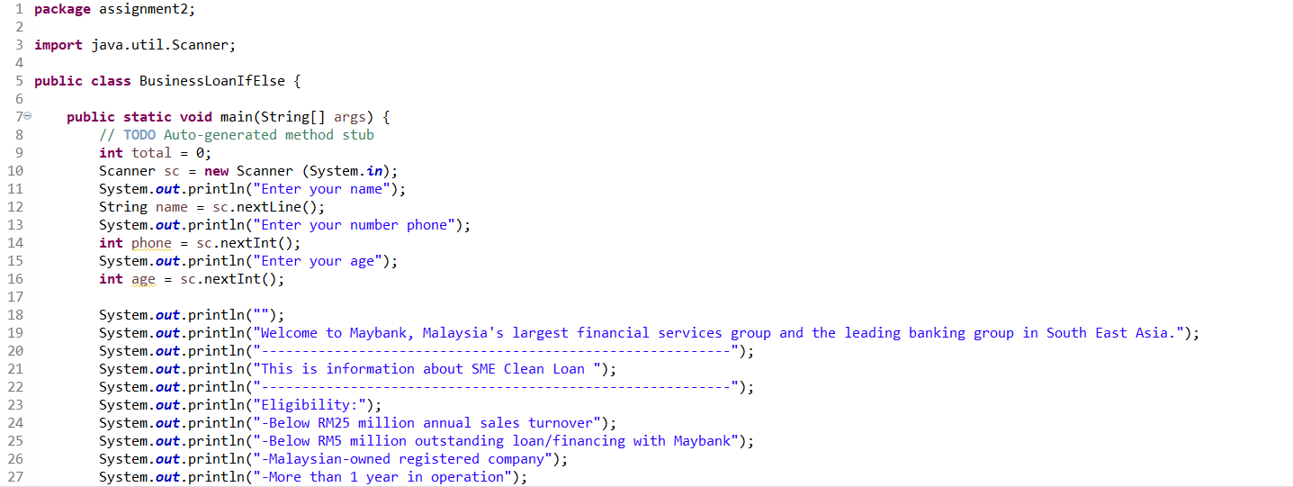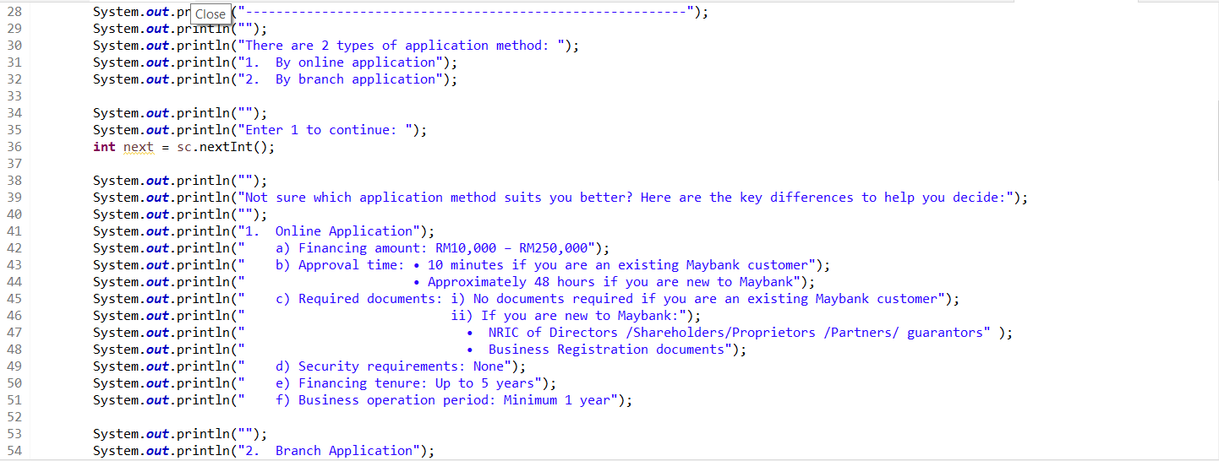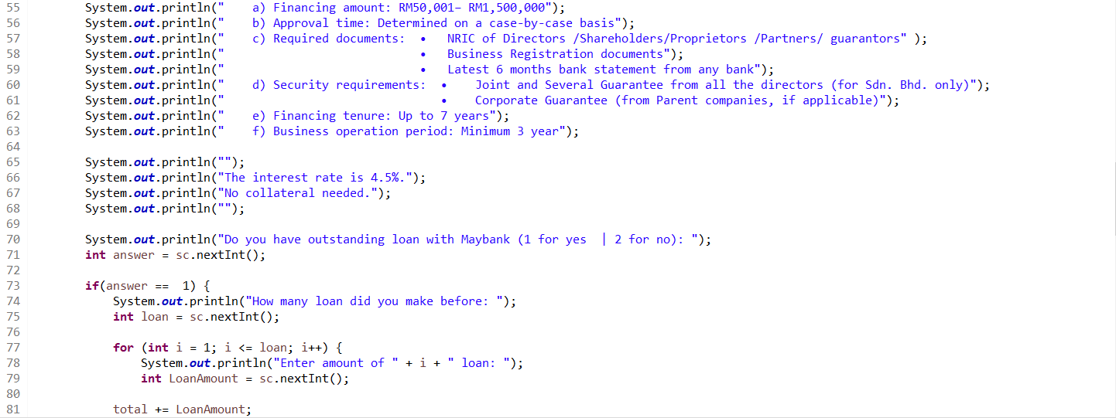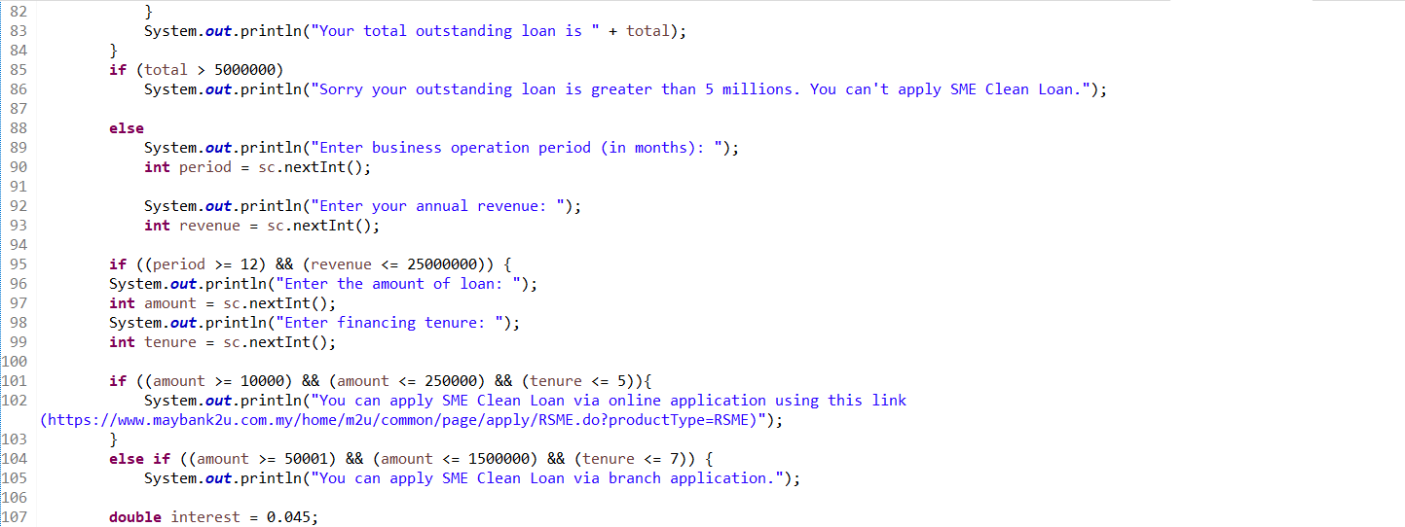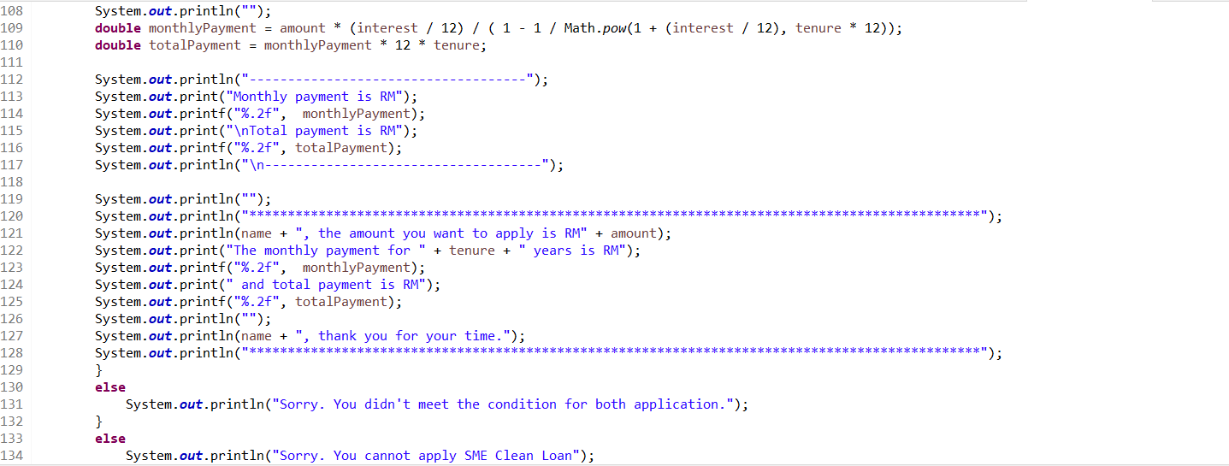

1. Output

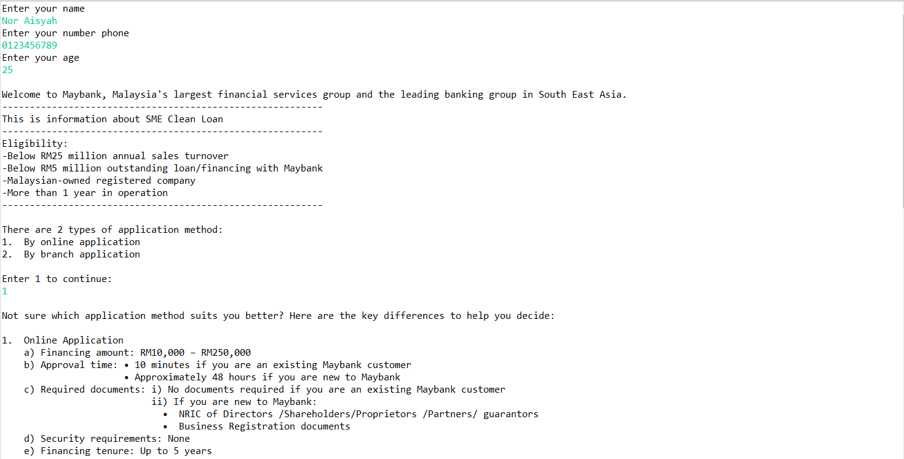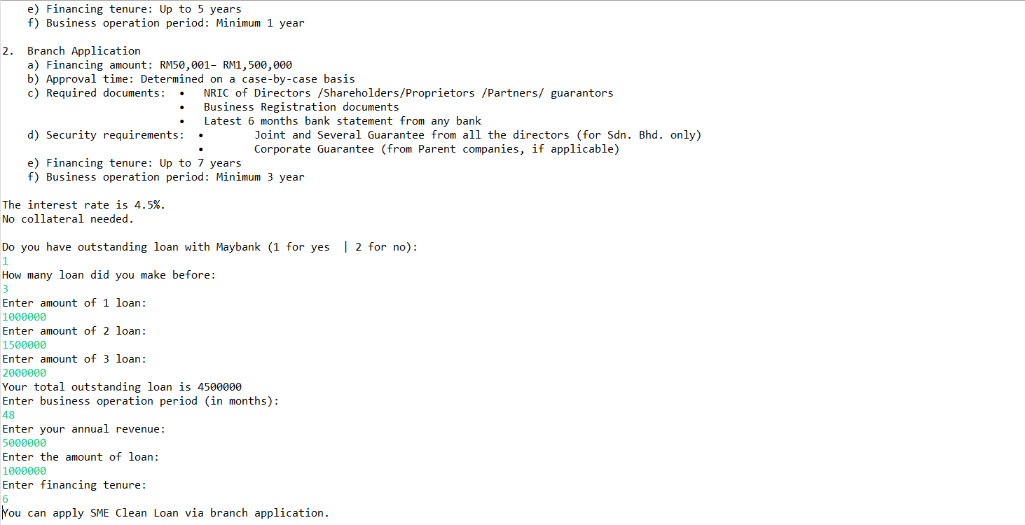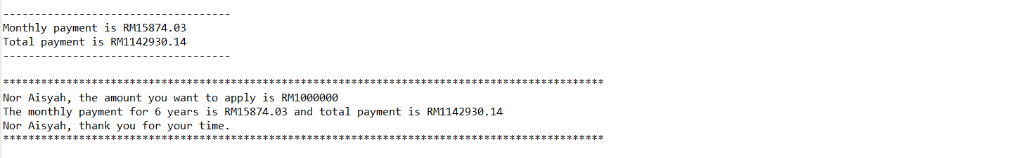



**A211 STIA1113 – PROGRAMMING 1 (GROUP C)**

**ASSIGNMENT 2**

**NAME: NUR ANIS SHAFIQAH BINTI MAZLAN**

**MATRIC NUMBER: 286987**

**TOPIC: BANK**

**SUBTOPIC: PERSONAL ACCOUNT**

**LECTURER: PROF. MADYA DR. AZMAN B YASIN**

**DUE DATE: 15 JANUARY 2022**



Since July 1983, Bank Islam Malaysia Berhad has been operating as an Islamic bank in Malaysia. Bank Islam is Malaysia's first Islamic bank, and it has played a significant role in the creation and growth of the country's Islamic financial system. Our current existence is focused on satisfying society's financial demands in the most sustainable and ethical way possible, while adhering to Shariah regulations and principles.

1. **Identify the problem:**

Encik Karim, a retired teacher from SMK Kubang Kerian, was 62 years old. Encik Karim wanted to pay his electric bill at Bank Islam Kubang Kerian in Kota Bharu, Kelantan, last week. Encik Karim was having problems transferring money to Tenaga Nasional Berhad for pay his house electric bill during the COVID-19 epidemic because people were advised to stay at home to prevent getting the virus. Encik Karim is looking for a solution from Bank Islam Malaysia to help him in paying his electric bill.

1. **Understand the problem:**

Our goal at Bank Islam is to create alternatives for everyone and improve their lives. We accomplish this through offering end-to-end financial systems that fit the various requirements of customers, as well as a platform for our stakeholders to grow, including our people, customers, and community.

According to the problem stated, Encik Karim is having problems paying a bill since he is unable to go to Bank Islam. This implies Encik Karim will have to find another way to pay his electric bill without having to go to Bank Islam.

1. **Identify alternative ways to solve the problem:**
2. Create an online service programme (GO Bank Islam) that requires customers to provide their information and allows them to transfer money via phone or laptop.
3. Contact Bank Islam employees and request that money be transferred by providing customer information.
4. **Select the best way to solve the problem from the list of alternative solutions:**



The first way is the best way that can be easier for Encik Karim to transfer his money. GO Bank Islam online service program can assist customer with their problems relating to the option that are available. A program will provide user information related to Recipient Bank, Recipient Account, Recipient Name, Recipient Reference, Amount. This program will lead the user through the process of transferring money and will calculate the total amount transmitted and any fees that may be charged based on the user's request.

1. **List instructions that enable you to solve the problem using the selected solution:**
2. User need to choose DuitNow.

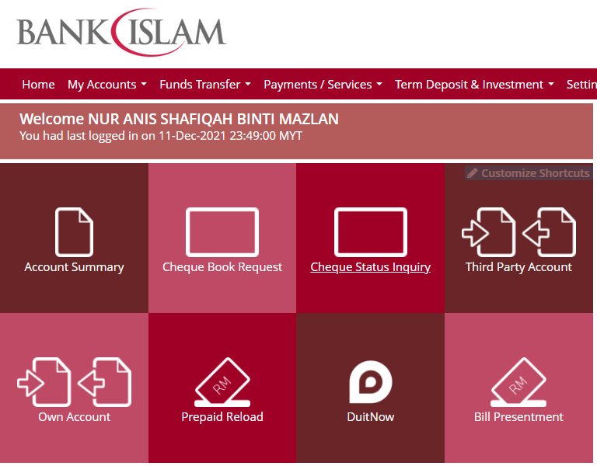

1. Ask user to key in their account number .

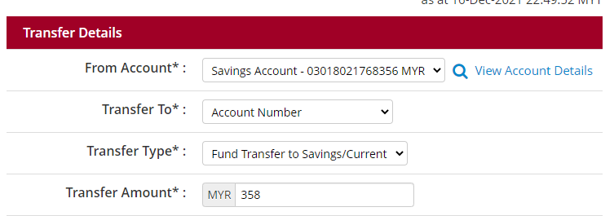

1. The program will display the details needed. (example: Recipient Bank Name, Recipient Account, Recipient Name, Recipient Reference, Amount ).

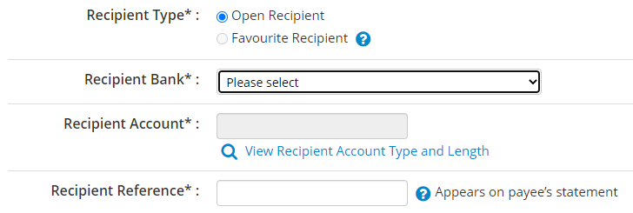



1. Ask user to key in the information needed.
2. The program will calculate the total amount transmitted and fees that have been charged.
3. The program will display the total amount transmitted and fees that have been charged to user.

EXAMPLE :

Account number : 764538

|  |  |  |
| --- | --- | --- |
| OPTION |  | FORMULA |
| DuitNow | Recipient Bank Name : Bank Muamalat  Recipient Account : 63518028  Recipient Name : Salman Bin Aziz  Recipient Reference : For food  Amount : RM176.00  *RM1.00 will be charged.  *Fee = 2% | RM176.00 + RM1.00 + (RM176.00*0.02)  = RM180.52 |

1. **Evaluate the solution**

Based on the solution that have been stated, Encik Karim can pay his electric bill by using GO Bank Islam services and choose DuitNow to transfer the money. Besides, regarding to the situation that Encik Karim or people who need to transfer their money but need to stay at home, also can make transaction money to others by using DuitNow too. They can use it on their phone or laptop at anywhere and anytime.

1. **Algorithm**

1.Choose DuitNow.

2.Insert user account number.

3.Insert recipient bank name.

4.Insert recipient account number.

5.Insert recipient name.

6.Insert recipient reference.

7.Insert transfer amount.

8.Wait until programme finish calculate total amount and fee that been charged.

9.Programme display total amount and fee that been charged.

10.Programme will ask user to play a guess number.

11.User need to guess the number until correct with 5 times attempt.

12.Insert the guess the number between 1 to 100.

13.Programme will tell if the number is greater or less than the guess the number

14.Programme will display the correct number after user has limit the attempt.

15.Programme will ask user to choose the gift.

16.User need to key in a number of the gift from the list.

17.Programme will display the gift that choosen by user.

1. **Pseudocode**

start

read next

read acc,bankname1,acc1,name1,references1,amount1

read next1

calculate total=(amount1+(amount1*0.02)+1)

display total

calculate number =1+(100*Math.random())

declare K=5

declare i,guess

for (i=0;i<K;i++)

read guess

if (number==guess)

display"Congratulation!!You guessed the number"

break;

else if (number>guess&&i!K-1)

display "The number is greater than that"+ guess

else if (number<guess&&i!K-1)

display "The number is less than that"+ guess

endif

endfor

if (i==K)

display number

if (gift==1)

display "You choose Notebook and 2021 Calendar as a gift"

else if (gift ==2)

display "You choose bag and 2021 Calendar as a gift"

else if (gift==3)

display "You choose Tumblr bottle and 2021 Calendar as a gift"

else if (gift==4)

display "You choose We Bare Bear and 2021 Calendar as a gift"

else if (gift==5)

display "You choose Colour Pencil and 2021 Calendar as a gift"

else

display "You don't choose any gift."

end

1. **Flowchart**

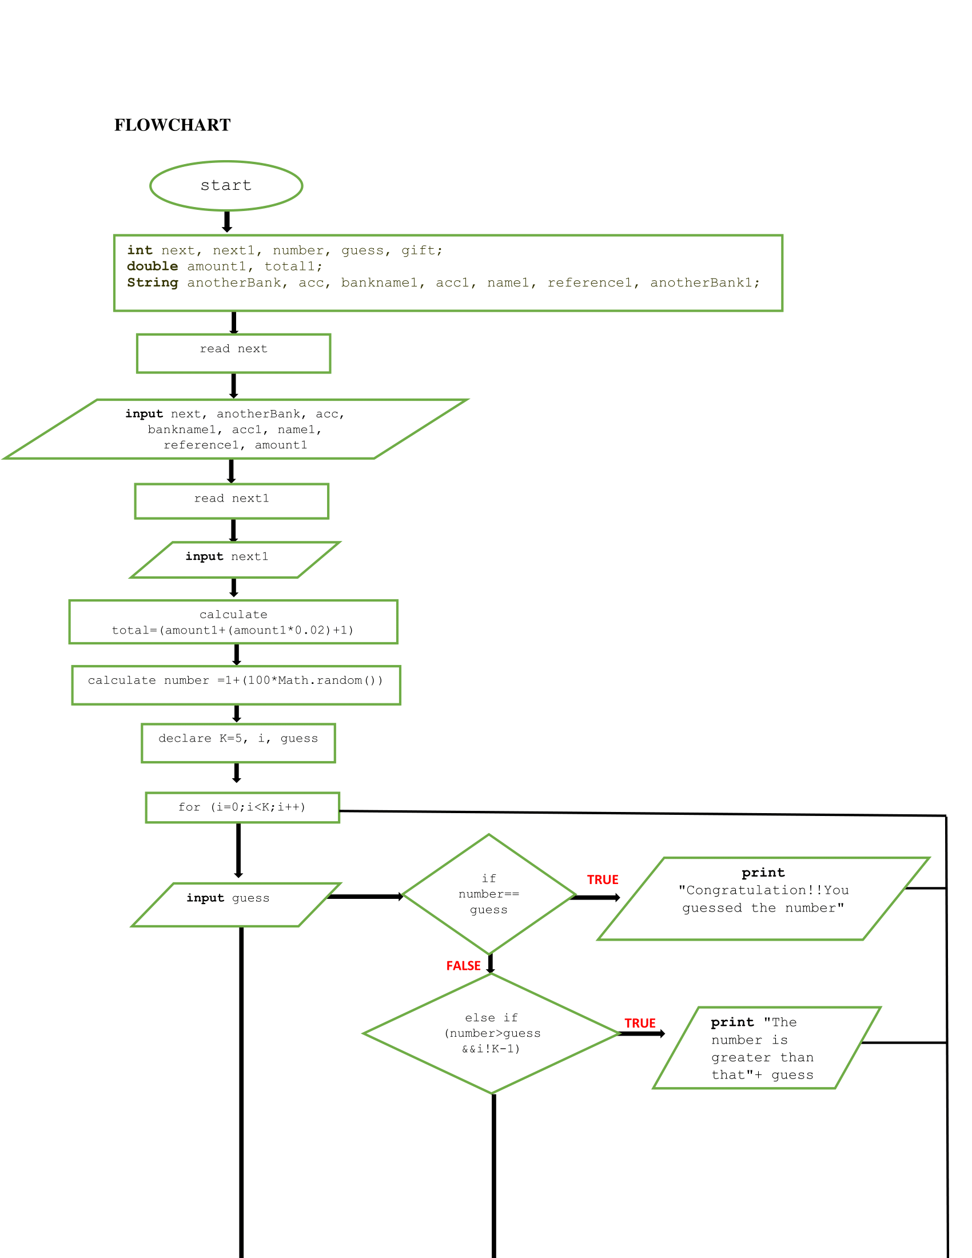

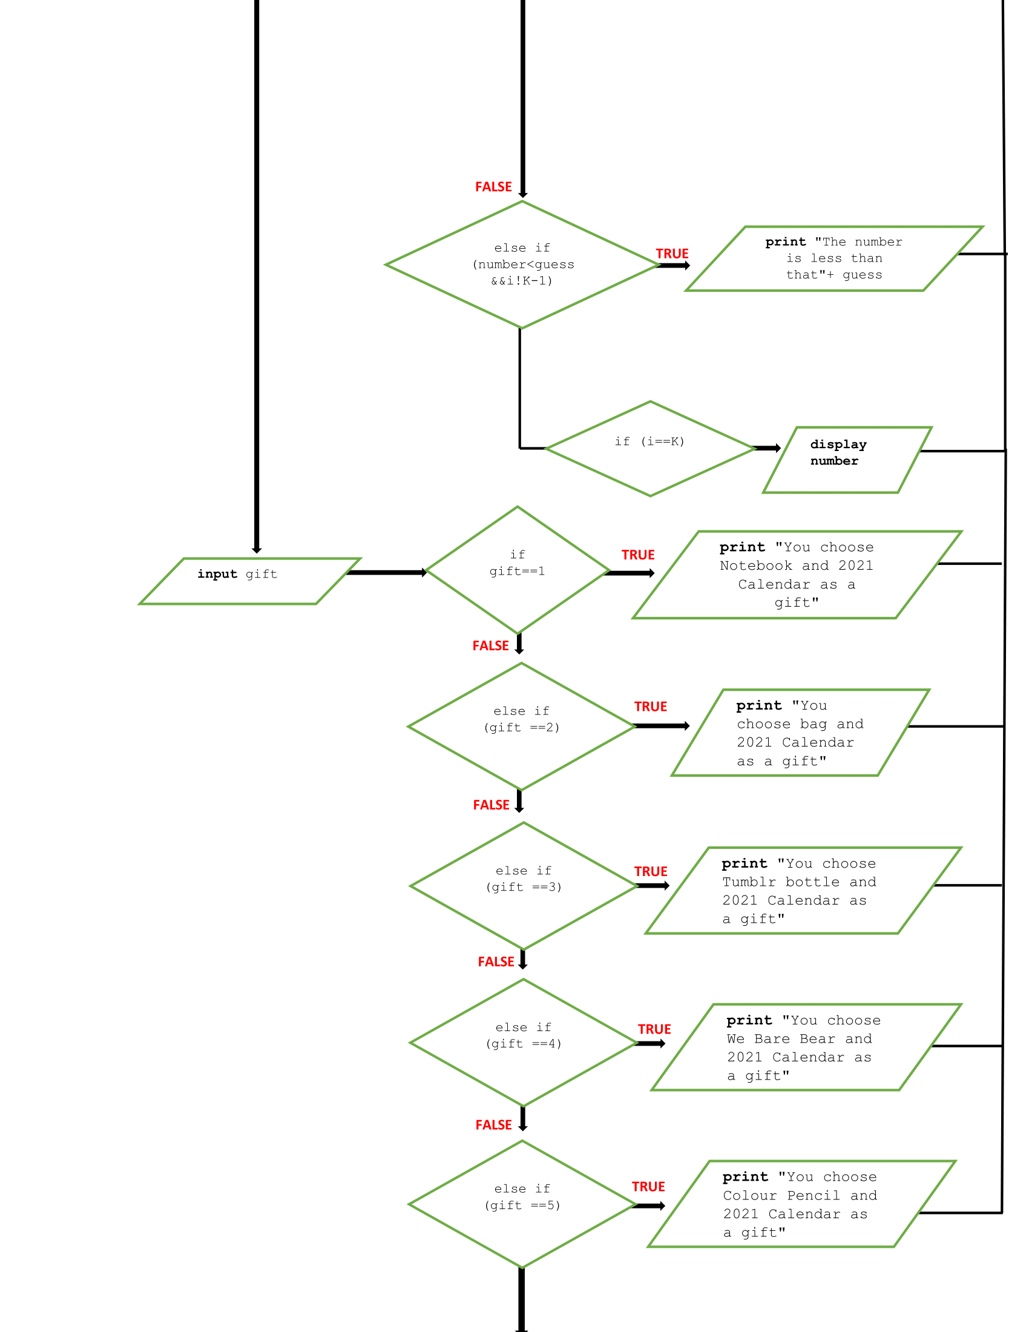

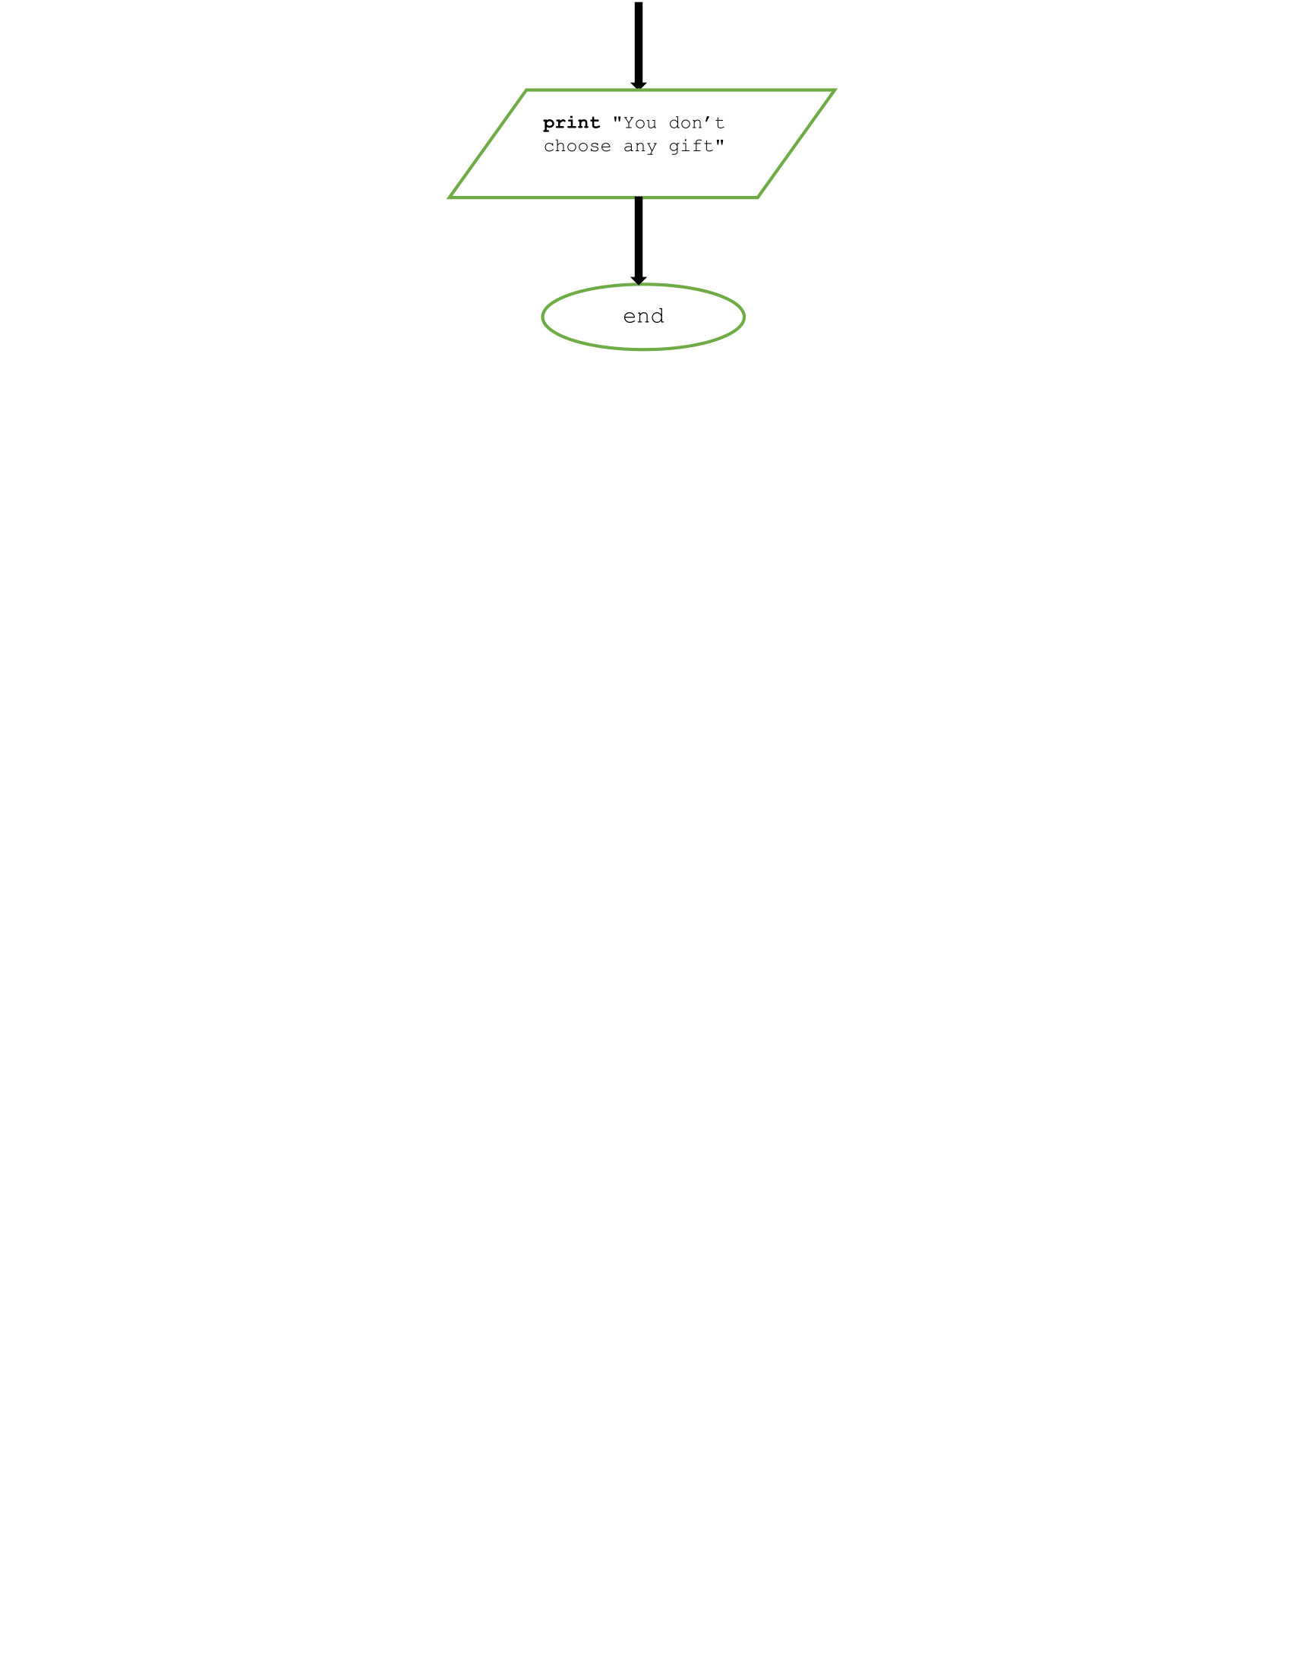

1. **Coding - Numerical Computation & Expression**

CODING :

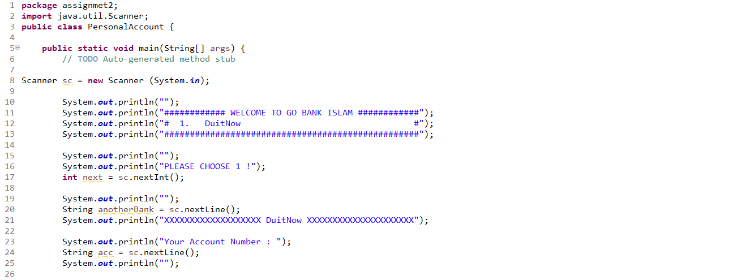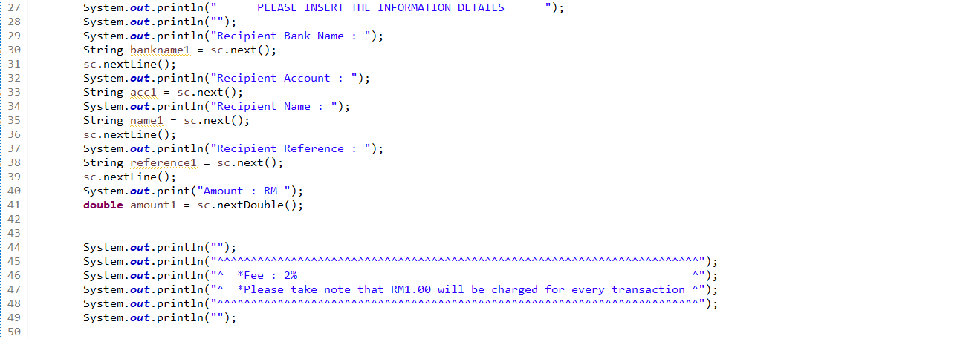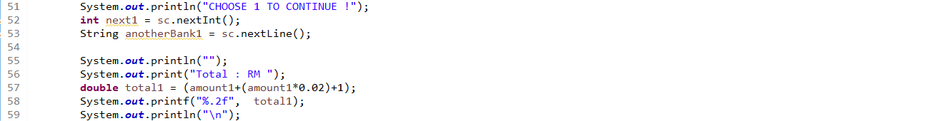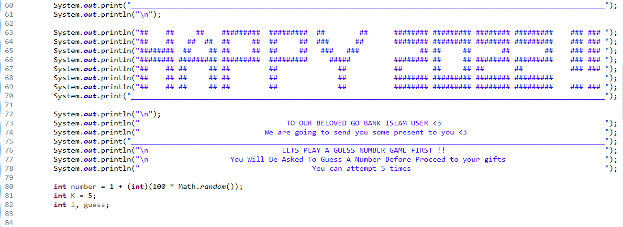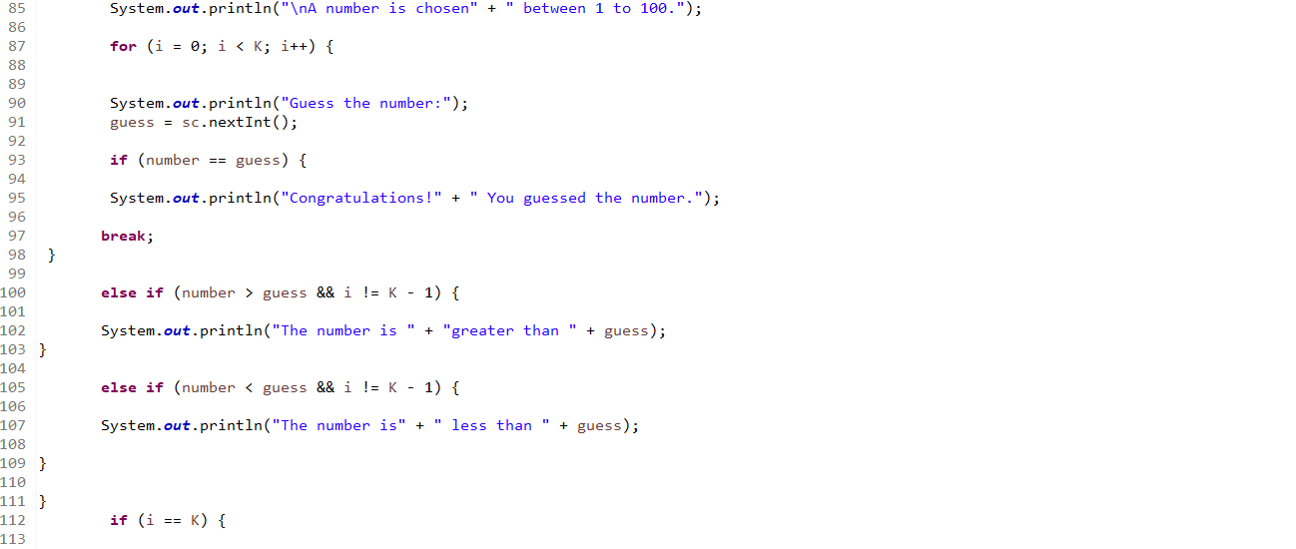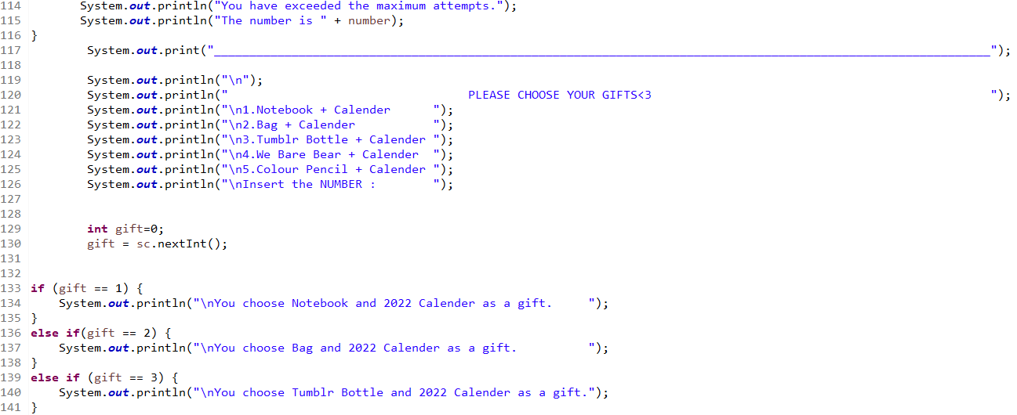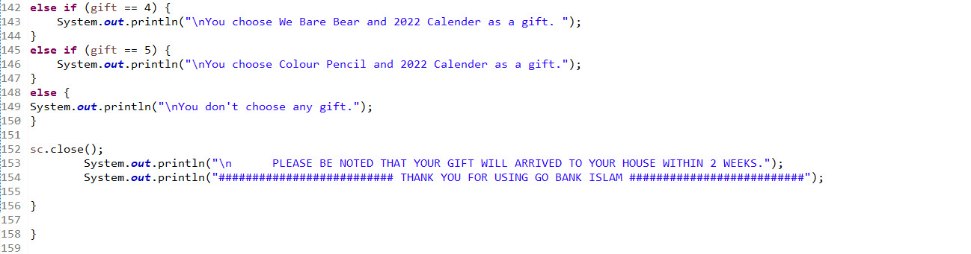

OUTPUT :

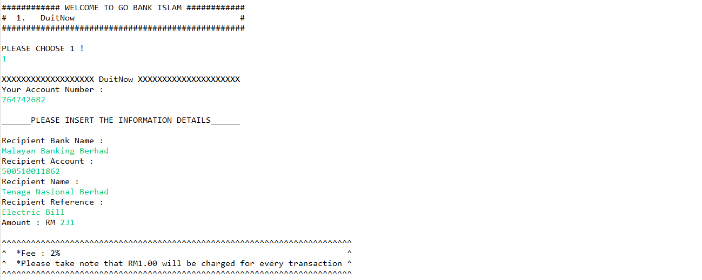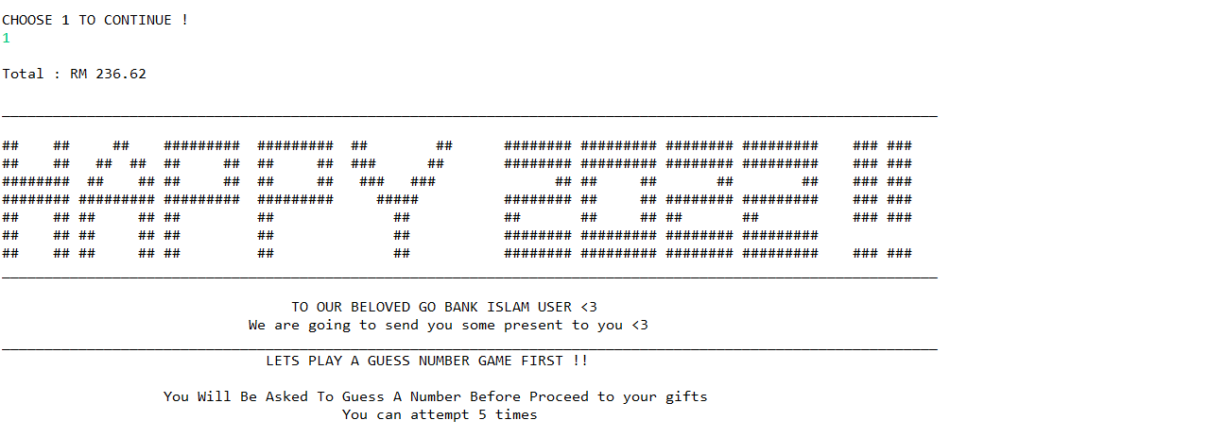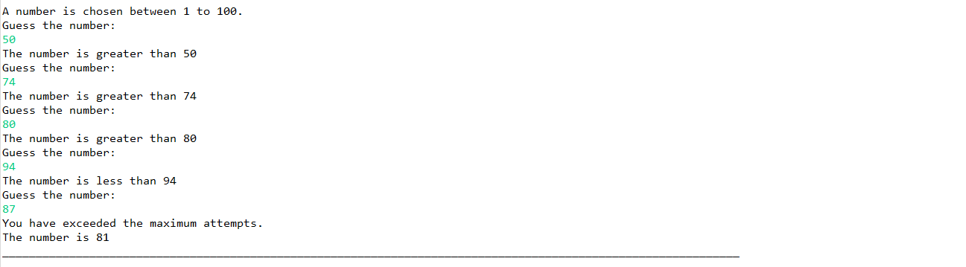

**ASSIGMENT 2:**

**THE UTILITY OF CREDIT CARD**



NAME: MUHAMMAD AFIQ IMRAN BIN AZIZAN

MATRIKS NO.: 286997

UNIVERSITY: UNIVERSITY UTARA MALAYSIA

CLASS: INFORMATION TECHNOLOGI, SCHOOL OF

COMPUTING

LECTURER: PROF. MADYA DR.AZMAN B YASIN

DUE DATE: 15 JANUARY 2022

**History:**

Credit Card is a plastic containing a means of identification that could make purchase of goods and service with lending money from bank. Credit Card first invented at United State of America in 1920s because it bother company that customer purchase made by company outlets. In 20th century the uses of credit card increasing and almost all people such as university student, teacher, and worker have credit card of their own.

**PROBLEM:**

In today era a lot to be done such as paying debt, buying plane ticket, booking a hotel and a lot more and you didn’t have much money to buy it all. Furthermore, you also didn’t want to bring a lot of money in your wallet because it could be stolen by people or you will get uncomfortable with the big wallet in your pocket. Not only that, you also need to buy things at once but can’t go at one place in a single time.

**UNDERSTANDING THE PROBLEM:**

The problem that you facing is that we don’t have much money to buy things that we want because the things is to expansive or we don’t have much money. Other than that, we don’t want our wallet to be stollen by thief when bring it with a lot of money. Furthermore, You don’t want to feel uncomfortable when bring big amount of money to places because it could make you unease. Lastly you want to purchase things in short amount of time without going many places.

**ALTERNATIVE TO SOLVE PROBLEM:**

One of the alternative that you can take is to make a purchases at home with online banking so that you can pay and buy things faster. Other than that, you can make loan with bank to get money to buy things you want. Plus, you also can bring wallet with big amount of money for example bringing RM 100 instead of RM 50 to make it easier bringing wallet around. Lastly, you can use credit card to buy things online and bring in wallet every time to purchase things.

**BEST ALTERNATIVE:**

Out of all the alternative, the best one is to use credit card to buy things online and bring it in wallet every time to purchase things. The reason why pick this is because it contains the other 3 alternative to solve problem. Not only that credit card also had ability that non purchase don’t have. The thing is called cashback, cashback is an amount of percentage that will be pay back to us from purchasing something with specific type of credit cards. You also need to pay bank monthly because we borrow money from bank and if you didn’t pay them that month the debt will become bigger next month.

**INSTRUCTION:**

1. Enter your name
2. Enter your credit card number
3. Enter expiration date
4. Enter your CCV
5. Purchase the things you want
6. Purchase successful

**TYPE OF CREDIT CARD:**

|  |  |  |  |  |
| --- | --- | --- | --- | --- |
| Type of credit card | Name of credit card | Specialty | picture | Interest rate |
| Type 1 | CIMB e Credit Card | none |  | 15% |
| Type 2 | CIMB Petronas Platinum MasterCard | -Give cashback of 7% on petrol money |  | 15% |
| Type 3 | Bank Rakyat Platinum Explorer Credit Card-i | -Give cashback of 5% on airlines and hotel booking |  | 15% |

**CALCULATION:**

|  |  |  |
| --- | --- | --- |
| Type of credit card | calculation | Description |
| Type 1 | -smartphone = 200  -laptop = 3000  -petrol = 50  - airplaneTicket = 4556  -Insurance = 74  -houseDebt = 650  -carDebt = 494  -HotelBooking = 200  -Totalpayment = 2000 + 3000 + 50 + 2556 + 74 + 650 +  494  -monthly payment= (2000/12) + (3000/12) + (50/12) +  (2556/12) + (74/12) + (650/12) +  (494/12)  -current money = 2000  -new money = 2000 + 3500  Money left = new money – monthly payment | -Thers nothing special about credit card type A because it’s just a basic one |
| Type 2 | *same as Type A  -petrol cashback = 50 *0.07  -balance = petrol cashback + new money | -Credit Card Type B will give you back 7% of petrol money in a year |
| Type 3 | *same as Type A  -airplane ticket cashback = (airplane ticket * 0.05) (4)  -hotel booking cashback = ((hotel booking * 0.05) (4)(7))  -last balance = balance 8 + airplane ticket cashback + hotel booking cashback | - Credit Card Type C will give you back 5% of airplane ticket and hotel booking |

**CALCULATION CREDIT CARD WITH DEBT:**

Calculate in June

|  |  |  |
| --- | --- | --- |
| description | Interest rate | calculation |
| -you have amount of debt RM1000  -you spend 100 at June 10  -you spend 400 at June 20  -you spend 100 at June 30 | 20% | **Calculating DPR:**  -20/365 = 0.054%  **Monthly Interest Rate:**  0.054 * 30 = 1.62%  **June 1 – 9:**  1000 * 9 = 9000  **June 10 – 19:**  1100 * 9 = 9900  **June 20 – 29:**  1500 * 9 = 13500  **June 30:**  1600 * 1 = 1600  monthly interest rate = (9000 + 9900 + 13500 + 1600) / 30    = RM1133  **Rate:**  Rate = (1.62/100) * 1133  = 18.35 |

**Evaluate the solution:**

In conclusion, buy using credit card it can help you a lot with purchasing and pay things up in no time and make things easier for us to pay without going everyplace to get things done and waste our energy. I hope that technology in credit card will improve because it help a lot to people like us to do some payment and purchasing easier.

**ALGORITHM:**

**PSEUDOCODE:**

Start

Read name, CCnum1, CCnum2, ED, CCV,

Total payment = smartphone + laptop + petrol + airplaneTicket + Insurance +

houseDebt + carDebt +HotelBooking

SmartphoneDebt1 = (smartphone/12)

laptopDebt1 = (laptop/12)

petrolDebt1 = (petrol/12)

airplaneTicketDebt1 = (airplaneTicket/12)

InsuranceDebt1 = (Insurance/12)

houseDebt1 = (HouseDebt/12)

carDebt1 = (carDebt/12)

HotelBookingDebt1 = (HotelBooking/12)

AllDebt1 = SmartphoneDebt1 + laptopDebt1 + petrolDebt1 + airplaneTicketDebt1

+ InsuranceDebt1 + houseDebt1 + carDebt1 + HotelBookingDebt1

Output  AllDebt1

Output “Your unpaid Debt for this Credit Card is RM1000:”

Debt1 = 1000 * 9

Debt2 = 6000 * 9

Debt3 = 7074 * 9

Debt4 = 7768 * 1

Currentmoney = 2000

NewMoney = Currentmoney + 3500

If ((CCnum1 == 11112222) && (CCnum2 == 33334444)

Output “You choose CIMB e Credit Card”

Balance = limit1 – totalpayment

Output balance

If ((CCnum1 == 76589473) && (CCnum2 == 87643508)

Output “You choose CIMB Petronas Platinum MasterCard”

Balance = limit1 – totalpayment

Cashback = (0.07/100)(petrol)

Balance2 = balance + Cahsback

Output balance, balance2

If ((CCnum1 == 50981234) && (CCnum2 == 11658925)

Output “You choose CIMB e Credit Card”

Balance = limit1 – totalpayment

Cashback = (((0.05/100) * (airplaneticket)) + ((0.5/100) * (Hotelbooking))

Balance2 = balance + cashback

Output Balance, Balance2

Else

Output “Unknown Credit Card”

While

i=0

if (I <= 3)

double MonthlyIntrestRate = DPR * 30

double rate = (MonthlyInterest/100) * MonthlyIntrestRate;

Output rate

double monthlydebt = AllDebt1 + rate;

Output monthlydebt

double moneyleft = newMoney - monthlydebt;

output moneyleft

i++;

Stop

**FLOWCHART:**

name, CCnum1, CCnum2, ED, CCV

limit 1 = 40000, limit 2 =80000, limit3 = 65000

Total payment = smartphone + laptop + petrol + airplaneTicket + Insurance + houseDebt + carDebt +HotelBooking

balance1 = limit1 -totalpayment

SmartphoneDebt1 = (smartphone/12)

laptopDebt1 = (laptop/12)

petrolDebt1 = (petrol/12)

airplaneTicketDebt1 = (airplaneTicket/12)

InsuranceDebt1 = (Insurance/12)

houseDebt1 = (HouseDebt/12)

carDebt1 = (carDebt/12)

HotelBookingDebt1 = (HotelBooking/12)

AllDebt1 = SmartphoneDebt1 + laptopDebt1 + petrolDebt1 + airplaneTicketDebt1

+ InsuranceDebt1 + houseDebt1 + carDebt1 + HotelBookingDebt1

Output balance1

Output AllDebt1

Output “Your unpaid Debt for this Credit Card is RM1000:

Debt1 = 1000 * 9

Debt2 = 6000 * 9

Debt3 = 7074 * 9

Debt4 = 7768 * 1

MonthlyInterest = (Debt1 + Debt2 + Debt3 + Debt4)/30

Currentmoney = 2000

NewMoney = Currentmoney + 3500

CCnum1==11112222 && CCnum2==33334444

false

true

Output “You choose CIMB e Credit Card”

Balance = limit1 – total payment

Output balance

CCnum1==76589473 && CCnum2==87643508

false

true

Output “You choose CIMB Petronas Platinum MasterCard”

Balance = limit1 – total payment

Cashback = (0.07/100) * (petrol)

Balance2 = Balance + Cashback

Output balance, Balance2

CCnum1==50981234 && CCnum2==11658925

true

Output “You choose Bank Rakyat Platinum Explore Credit Card-i”

Balance = limit1 – total payment

Cashback = ((0.05/100) * (Airplaneticket)) +((0.05/100) * (HotelBooking))

Balance2 = Balance + Cashback

Output balance, Balance2

While i <= 3

Output “Unknown Credit Card”

else

DPR = 15/365

MonthlyIntrestRate = DPR * 30

rate = (MonthlyInterest/100) * MonthlyIntrestRate

monthlydebt = AllDebt1 + rate

moneyleft = newMoney - monthlydebt

i++

Output rate, monthlydebt, moneyleft

**CODING:**

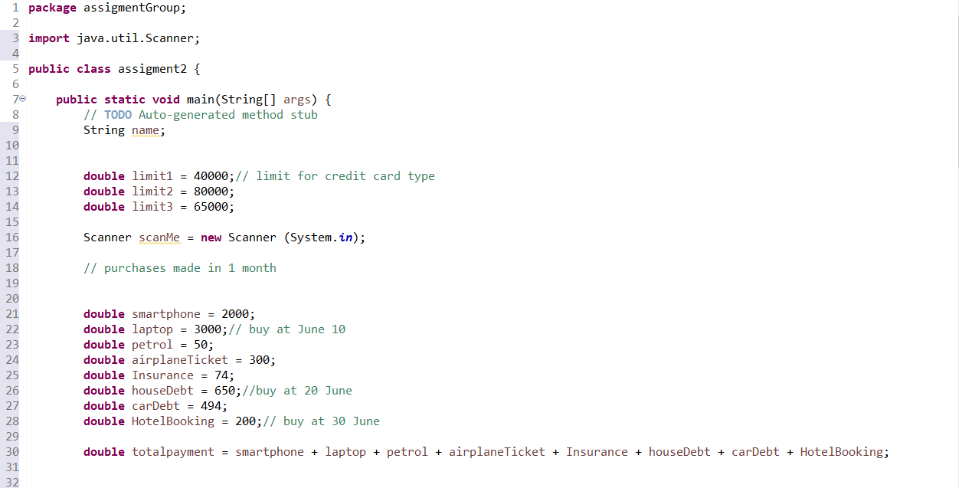

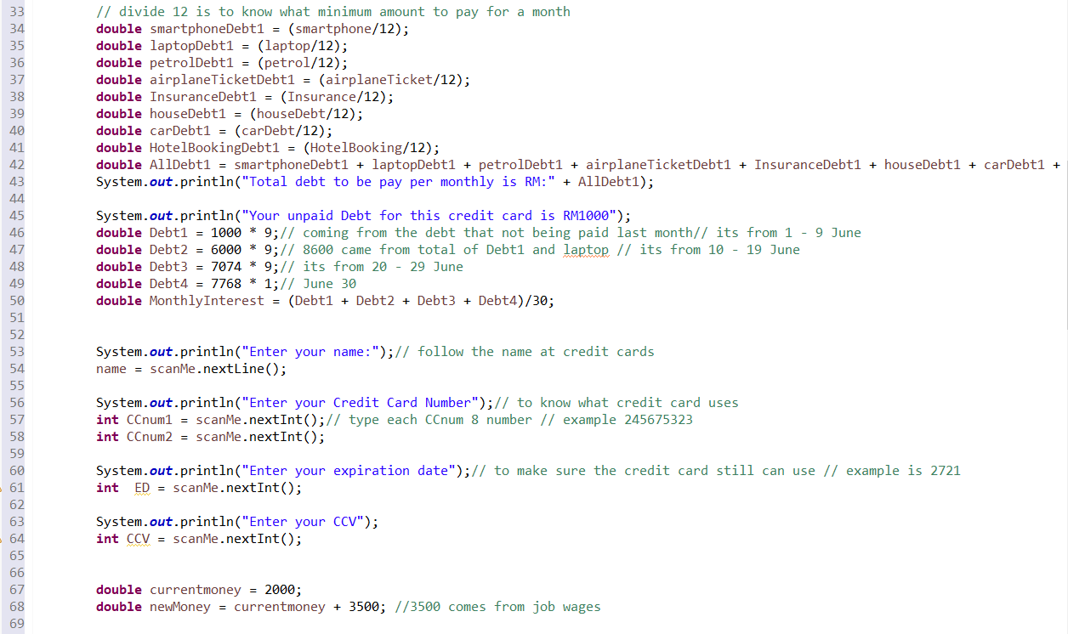

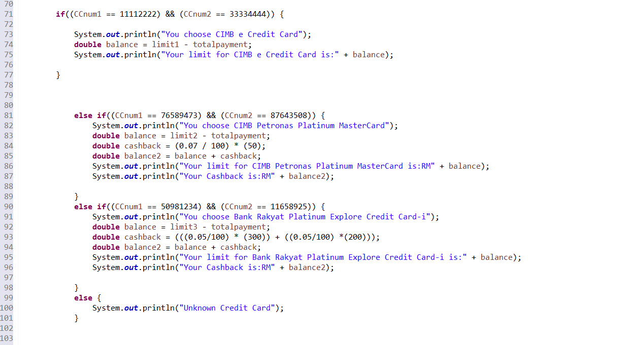

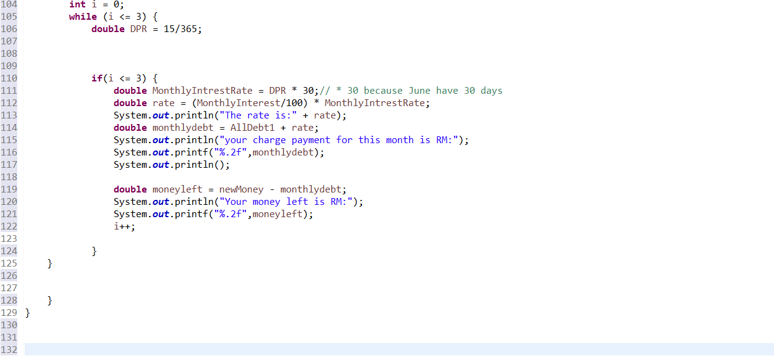

**OUTPUT:**

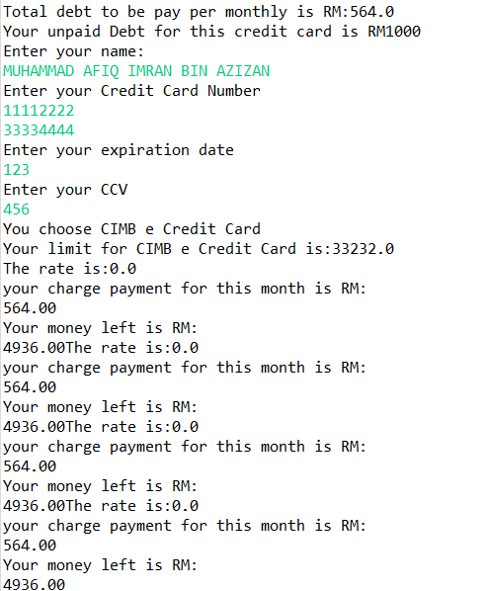



**A211 STIA1113 – PROGRAMMING 1 (GROUP C)**

**ASSIGNMENT 2**

**NAME: MUHAMMAD YASRI BIN ROSLAN**

**MATRIC NUMBER: 287021**

**TOPIC: BANK**

**SUBTOPIC: HOUSING LOAN**

**LECTURER: PROF. MADYA DR. AZMAN B YASIN**

**DUE DATE: 15 JANUARY 2022**

1. **Identify the problem**

A home loan also known as a mortgage is a contract between a borrower and a lender that allows the borrower to borrow money to purchase a home, apartment, condo, or other living property. A home loan is often repaid over 10, 15 or 30 years. The majority of people consider buying a home to be the most important financial decision they will ever make. Most people can't afford to pay cash for the entire property up front because residences can cost hundreds of thousands, if not millions, of dollars. As a result, they will need to obtain a house loan which borrow from a bank, credit union, or specialty mortgage lender for low-income borrowers such as CIMB Bank, Maybank or Bank Islam. For example Maybank is Malaysia’s largest financial services group and has a strong regional presence in South East Asia. Maybank offers a full range of financial products and services covering consumer banking, corporate and investment banking, Islamic banking, asset management, wealth management, insurance and takaful, and private banking. All of this is a importing thing to people to gain their loan to buy property or to invest for future. The situation that we can see is that new borrowers are hesitant to apply for a loan because they are unsure of how much they will have to pay if they apply for one and how much their entire total payment would be, including interest, throughout the life of the contract. Next the user also don’t know which one house that suitable with their budget and then they juts buy a house without thinking that price.

1. **Understand the problem**

Due to applicants' lack of awareness of the process, home loan applications in Malaysia have a high incidence of denial. According to Bank Negara Malaysia, home loan refusal rates reached nearly 60% last year (BNM). This is because many borrowers are uninformed of how much they can borrow and what they must remember to avoid their loan being rejected by the bank. This is a problem that many borrowers, particularly first-time borrowers, experience. The majority of them always apply for a loan based on the price of the home they want, but they overlook variables such as the amount they must repay. This is critical because when a borrower purchases a home without first calculating the amount they must repay, it can cause certain borrowers to have difficulty repaying their loans, and in some cases, this can lead to bankruptcy. After that most of them always buy the home without do a research such as type of house, price and the number of house loan. As a result, borrowers must understand how to determine the amount owed and the overall amount owed on the contract. After that most of them always buy the home without do a research such as type of house, price and the number of house loan.

1. **Identify alternative ways to solve the problem**
2. Make a system calculating for help borrower to calculate their amount of payback and the total amount payback in housing loan and give a choice to the user home package.
3. Make system to give a information for borrower to know more about housing loan applying.

**4.Select the best way to solve the problem from the list of alternative solution**

The best way to solve this problem are first way which is make a system calculation for help borrower to calculate their amount of they need to pay. This is because when borrower know how much they need to pay for monthly so they can find a house price that suitable with they salary. Next this calculation will help a lot to borrower especially for borrower who are the first time borrow loan from the bank because it can reduce a time for borrower deal with a banker about a amount. Also when borrower buy a house that can they able to pay this can make a low risk for borrower bankrupt. Next the system give a user suggestion about home package so the user can choice which one home package that suitable with their budget.

**5.List instruction that enable you to solve the problem using the selected solution**

1. Borrower need to declare some information
2. The system will help borrower to calculate the total of amount according the information in the first part
3. The system will give the total amount of payback and also they total amount in the term of contract
4. The system will ask user if their interested with home suggestion
5. If user interested the system will ask for budget amount
6. After that the system will give a suggestion home package according amount that user declare
7. The user can enter the package number if their interested and the system will calculate the amount of monthly payment according that price of the package
8. The user can choose that want a repeat or not the calculation.

**The calculation**

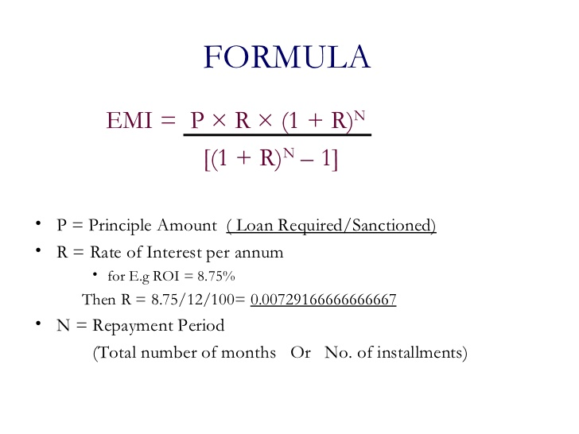

|  |  |  |
| --- | --- | --- |
| **NO** | **LOAN TERM** | **TOTAL** |
| 1. | Principal | Rm 249,000 |
| 2. | Interest rate  3.80 / 12 / 100 | 3.80 / 12 /100  0.00031 |
| 3. | Term of years  Years * 12 | 30 * 12  360 years |
| 4. | Monthly payment  249,000 * 0.31(1+ 0.31) * 30 years  (1+ 0.31) 30 years - 1 | Rm 1160 |
| 5. | Total Payment in contract  Total monthly payment * term of years * 12 | Rm 417,684 |
| 6 | The monthly payment house price  House price / 200 | Rm 130000/200  = Rm 650 |

1. **Evaluate the solution**

In the end of this system will help the borrower budget planning to buy a house because they already know how much the total they need to payment. This also make a borrower feel save to apply loan to the bank. Next the system will help the user to choice the house package according with the amount of budget that their want.this can make the user know which house that their can afford to buy.

1. **Algorithm**
2. Start
3. Enter the name
4. Enter the loan amount
5. Enter the interest rate
6. Enter the number of years
7. The system will calculate the monthly payment and the total of payment
8. The system will ask the user about suggestion home package
9. The user need to declare the budget
10. The system will detect which one home package suitable with their budget
11. If user agree with the package the system will help user to calculate the monthly payment according with home price
12. End
13. **Pseudocode**
14. START
15. Read the name
16. Read the loan amount
17. Read the interest rate
18. Calculate the monthly interest rate
19. Read the number of years
20. Calculate the monthly payment = loan * monthly interest (1-monthlyinterest)*years / (1+ monthlyinterest , years)-1
21. Calculate the total payment = monthlypayment * years
22. The system will come up with the total monthly payment and the total payment
23. The system will ask about suggestion home package
24. Read the amount budget
25. Come out the home package
26. Calculate the monthly payment
27. END
28. **Flowchact**

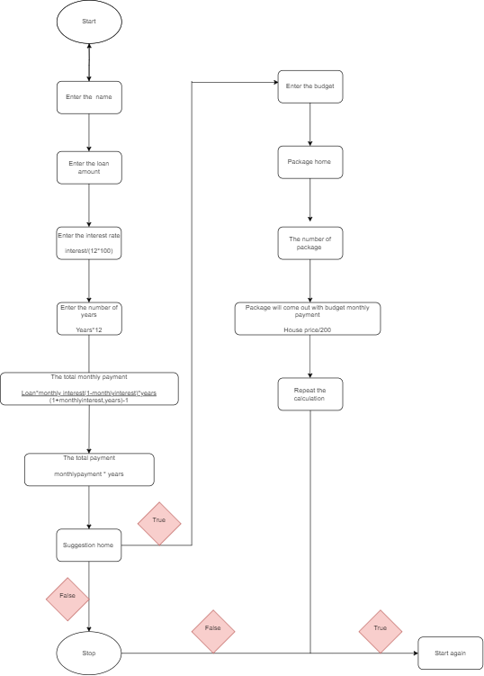

1. **Coding**

|  |
| --- |
| **package** Assingment2;  **import** java.util.Scanner;  **public** **class** ifelseHousingLoan {  **public** **static** **void** main(String[] args) {  // **TODO** Auto-generated method stub    Scanner sc = **new** Scanner(System.***in***);    String repeat , home;    **double** pay=0;    **do**{      System.***out***.println("===== MAYBANK HOUSING LOAN CALCULATOR ======");      System.***out***.println("\nENTER YOUR NAME : ");  String name = sc.next();      System.***out***.println("\nENTER THE LOAN AMOUNT : ");    **double** loan =sc.nextDouble();    System.***out***.println("\nENTER THE INTERST RATE : ");    **double** interest = sc.nextDouble();    **double** monthlyinterest = interest /(12*100);      System.***out***.println("\nENTER THE NUMBER OF YEARS : ");    **double** time = sc.nextDouble();    **double** years = time * 12;      **double** monthlypayment= (loan*monthlyinterest*Math.*pow*(1+monthlyinterest,years))/(Math.*pow*(1+monthlyinterest,years)-1);    **double** totalpayment = monthlypayment * years;      System.***out***.println("\n*---YOUR TOTAL MONTHLY PAYMENT AND TOTAL PAYMENT---*");    System.***out***.println("\nTHE TOTAL MONTHLY PAYMENT IS RM "+ (Math.*round*(monthlypayment)));    System.***out***.println("\nTHE TOTAL PAYMENT IS RM " + (Math.*round*(totalpayment)));    System.***out***.println("\n**********THANK YOU FOR USING MAYBANK CALCULATOR **********");      System.***out***.print("\nDO YOU INTERESTED WITH HOUSE SUGGETION? [Y/N] :");  home=sc.next();      **if**(home.equalsIgnoreCase("Y")){  System.***out***.print("\nPLEASE ENTER YOUR BUDGET PRICE :");  loan=sc.nextDouble();    **if**(loan>=100000 && loan<=200000){  home="1";  pay=(130000/200);  System.***out***.println("PACKAGE HOME 1 ");  System.***out***.println("APARTMENT");  System.***out***.println("PRICE RM 130000 ");  System.***out***.println("HOUSE LOAN 30 YEARS");    }    **else** **if** (loan>=200000 && loan<=300000){  home="2";  pay=(270000/200);  System.***out***.println("PACKAGE HOME 2");  System.***out***.println("SINGLE STOREY ");  System.***out***.println("PRICE RM 270000 ");  System.***out***.println("HOUSE LOAN 30 YEARS ");    }    **else** **if** (loan>=300000 && loan<=400000) {  home="3";  pay=(320000/200);  System.***out***.println("PACKAGE HOME 3");  System.***out***.println("DOUBLE STOREY ");  System.***out***.println("PRICE RM 320000 ");  System.***out***.println("HOUSE LOAN 30 YEARS ");    }    **else** **if** (loan>=400000 && loan<=600000) {  home="4";  pay=(550000/200);  System.***out***.println("PACKAGE HOME 4");  System.***out***.println("SEMI D DOUBLE STOREY ");  System.***out***.println("PRICE RM 550000 ");  System.***out***.println("HOUSE LOAN 30 YEARS ");    }    **else** **if** (loan>=600000 && loan<=1000000) {  home="5";  pay=(1000000/200);  System.***out***.println("PACKAGE HOME 5");  System.***out***.println("BUNGLOW");  System.***out***.println("PRICE RM 1000000 ");  System.***out***.println("HOUSE LOAN 30 YEARS ");  }    System.***out***.print("\n***********************************************");  System.***out***.print("\nPLEASE ENTER PACKAGE NUMBER IF YOU INTERESETED : ");  home=sc.next();  home.toUpperCase();    **switch**(home){  //case "1":  **case** "1":System.***out***.println("\nPAKEJ "+home);  System.***out***.printf("\nYOUR MONTHLY PAYMENT WILL BE :RM %.2f%n",pay);  **break**;    **case** "2":System.***out***.println("\nPAKEJ "+home);  System.***out***.printf("\nYOUR MONTHLY PAYMENT WILL BE :RM %.2f%n",pay);  **break**;    **case** "3":System.***out***.println("\nPAKEJ "+home);  System.***out***.printf("\nYOUR MONTHLY PAYMENT WILL BE :RM %.2f%n",pay);  **break**;    **case** "4":System.***out***.println("\nPAKEJ "+home);  System.***out***.printf("\nYOUR MONTHLY PAYMENT WILL BE :RM %.2f%n",pay);  **break**;    **case** "5":System.***out***.println("\nPAKEJ "+home);  System.***out***.printf("\nYOUR MONTHLY PAYMENT WILL BE :RM %.2f%n",pay);  **break**;  }    }**else**{    System.***out***.println("\nTHANK YOU" );    }    System.***out***.print("\nDO YOU WANT REPEAT THE CALCULATION AGAIN ? [Y/N] :");  repeat=sc.next();    }**while**(repeat.equals("Y")||repeat.equals("y"));    System.***out***.println("\nTHANK YOU" );      }    } |

Output

|  |
| --- |
| ===== MAYBANK HOUSING LOAN CALCULATOR ======  ENTER YOUR NAME :  yasri  ENTER THE LOAN AMOUNT :  200000  ENTER THE INTERST RATE :  3.80  ENTER THE NUMBER OF YEARS :  30  *---YOUR TOTAL MONTHLY PAYMENT AND TOTAL PAYMENT---*  THE TOTAL MONTHLY PAYMENT IS RM 932  THE TOTAL PAYMENT IS RM 335489  **********THANK YOU FOR USING MAYBANK CALCULATOR **********  DO YOU INTERESTED WITH HOUSE SUGGETION? [Y/N] :y  PLEASE ENTER YOUR BUDGET PRICE :150000  PACKAGE HOME 1  APARTMENT  PRICE RM 130000  HOUSE LOAN 30 YEARS  ***********************************************  PLEASE ENTER PACKAGE NUMBER IF YOU INTERESETED : 1  PAKEJ 1  YOUR MONTHLY PAYMENT WILL BE :RM 650.00  DO YOU WANT REPEAT THE CALCULATION AGAIN ? [Y/N] :n  THANK YOU |



**A211 STIA1113 – PROGRAMMING 1 (GROUP C)**

**ASSIGNMENT 2**

**NAME: MUHAMAD AIMIL DANIEL BIN LATIF**

**MATRIC NUMBER: 287056**

**TOPIC: BANK**

**SUBTOPIC: INVESTMENT**

**LECTURER: PROF. MADYA DR. AZMAN B YASIN**

**DUE DATE: 15 JANUARY 2022**

1. **Identify the Problem**

Regarding from assignment 1, the problem is still same which is to find other alternative to expand money. However, they do not know on when the maturity date of their investment.

1. **Understand the problem**

From the problem, the customer or investors wants to know their date of maturity and at the same time, to simplify the process.

1. **List Instructions that Enable you to Solve the Problem Using the Selected Solution**
   1. Ask user to key in their name, number phone and account number.
   2. Ask user to choose 1
   3. Enter Investment Amount and Investment Tenure.
   4. Wait for the system to calculate the amount of profitability.
   5. System will display the name, number phone, account number, profit payable to the Customer, accumulated profits and total amount.
   6. Repeat for another customer.
   7. Display how many customers valid in one day.
   8. Display customer information.
2. **Evaluate the Solution**

From this, the system will help the both side which is from investors sides and bank sides. For investor, they do not have to key in percentage of net return to customer anymore because it will automatically calculate depends on invest amount and the date of maturity will show depends on when their access the system. Otherwise, the system also make easier for the banker since it will print output how many customers in one day and list of the customer.

1. **ALGORITHM**

1. Start

2. Enter name, phone number, account number.

3. Select investment.

4. Enter investment amount, investment tenure.

5. System calculate the input.

6. Display customer date register, name, phone number, account number, maturity date profit payable to cust, accumulated profits and total amount.

8. Scan new input.

9. Output number of visitors

10. Output list name, phone number and account number.

11. End

1. **PSEUDOCODE**

Start

do {

Input name

Input phone_number

Input acc_number

Input Select Investment

Input invest_amount

Input invest_tenure

percent = 0

if((invest_amount >= 1000)&&(invest_amount <= 10000))

percent =3.2

else if((invest_amount >= 100001)&&(invest_amount <= 30000))

percent =3.8

else if((invest_amount >= 100001)&&(invest_amount <= 30000))

percent =4.2

noOfDays = 0

if(invest_tenure == 3)

noOfDays = 90

else if (invest_tenure == 6)

noOfDays = 180

else if(invest_tenure == 12)

noOfDays = 365

Calendar cal = Calendar.*getInstance*()

Date cdate = cal.getTime()

cal.add(Calendar.***DAY_OF_YEAR***, noOfDays)

Date date = cal.getTime()

profitpayabletocust = invest_amount * percent/100 * 30/365

accumulatedprofit = profitpayabletocust * invest_tenure

totalamount = invest_amount + accumulatedprofit

Output "Register Date" + cdate

Output "NAME" + name

Output "PHONE NUMBER” + phone_number

Output "ACCOUNT NUMBER" + Account Number

Output "Maturity Date" + date,

Output "PROFIT PAYABLE TO CUSTOMER"+ profitpayabletocust

Output "ACCUMULATED PROFIT" + accumulatedprofit

Output "TOTAL AMOUNT" + totalamount

}

Ready for next input?

While( (pick == ‘Y’) || (pick == ‘y’))

Output The number of valid visitors to your websites today is: " +(a-1)

Would you like to see the details of your customer for today? (Y/y)

if ( (pick == ‘Y’) || (pick == ‘y’))

Output name, phone_number, acc_number

End

1. **FLOWCHART**

Start

INPUT

name, phone_number, acc_number

INPUT

Select Investment

INPUT

invest_amount, invest_tenure

invest_amount >=

1000 && invest_amount

<= 10000

invest_amount >=

10001 && invest_amount

<= 30000

invest_amount>=

30001 && invest_amount

<= 50000

invest_tenure

3

==

invest_tenure

==

6

invest_tenure

12

==

percent = 3.2

percent = 3.8

percent = 4.2

noOfDays = 90

noOfDays = 180

noOfDays = 365

Calendar cal = Calendar.getInstance()

Date cdate = cal.getTime()

cal.add(Calendar.DAY_OF_YEAR,

noOfDays)

Date date = cal.getTime()

profitpayabletocust = invest_amount * percent/100 *

30/365

accumulatedprofit = profitpayabletocust *

invest_tenure

totalamount = invest_amount + accumulatedprofit

OUTPUT "Register Date" + cdate, "NAME" + name,

"PHONE NUMBER' + phone_number", "ACCOUNT

NUMBER" + Account Number,

"Maturity Date" + date,

"PROFIT PAYABLE TO CUSTOMER"+

profitpayabletocust, "ACCUMULATED PROFIT" +

accumulatedprofit, "TOTAL AMOUNT" + totalamount

While Ready for next

input =="Y" | "y"

OUTPUT

The number of valid visitors to your websites

today is: + (a-1)

Would you like

to see the details of

your customer for today?

==

"Y" | "y"

OUTPUT

name, phone_number,

acc_number, invest_amount

THANK YOU FOR USING OUR

SERVICE. SEE YOU AGAIN!

End

1. **Coding – Numerical Computation & Expression**

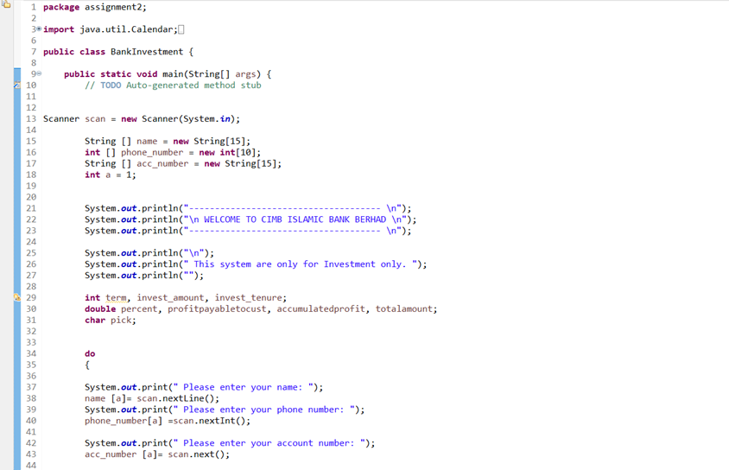

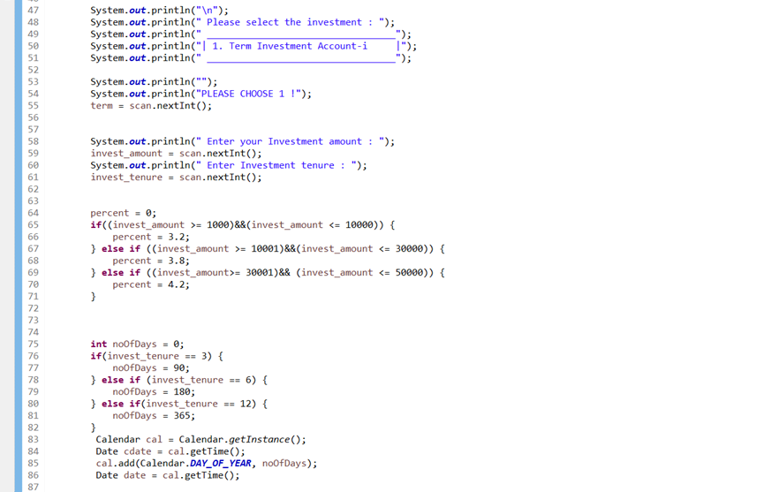

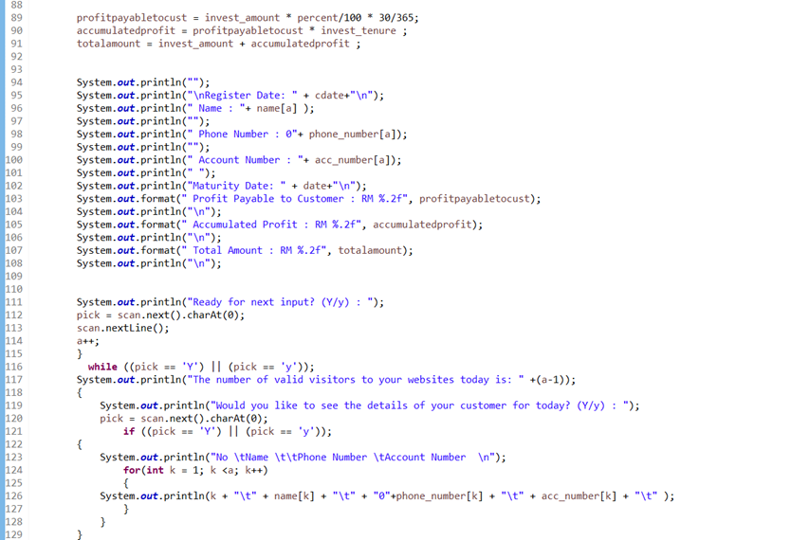

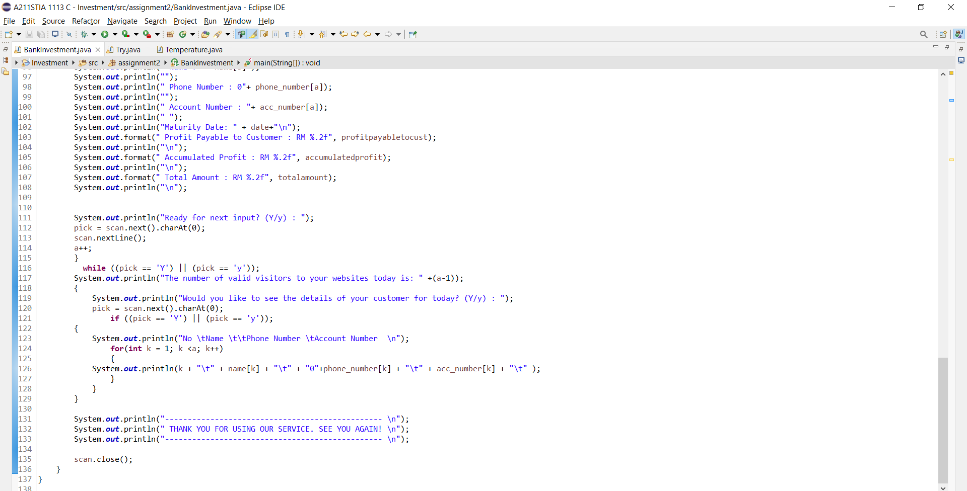

**Output**

